|  |
| --- |
| **18EES101J-BASIC ELECTRICAL AND ELECTRONICS ENGINEERING (LAB)** |
| **RECORD**  **SEMESTER II**    **ACADEMIC YEAR: 2021-22**  **NAME :**  **REG. NO.:**  C:\Users\System 1\Desktop\11.png  **DEPARTMENT OF ELECTRICAL & ELECTRONICS ENGINEERING**  **FACULTY OF ENGINEERING & TECHNOLOGY**  **SRM INSTITUTE OF SCIENCE AND TECHNOLOGY**  (Formerly SRM University, Under section 3 of UGC Act, 1956)  **S.R.M. NAGAR, KATTANKULATHUR – 603 203**  **KANCHEEPURAM DISTRICT** |



**SRM Institute of Science and Technology**

(Deemed to be University)

**S.R.M. NAGAR, KATTANKULATHUR -603 203**

**KANCHEEPURAM DISTRICT**

**BONAFIDE CERTIFICATE**

**Register No\_\_\_\_\_\_\_\_\_\_\_\_\_\_\_\_\_\_\_\_\_\_\_\_\_\_\_\_\_\_**

Certified to be the bonafide record of work done by \_\_\_\_\_\_\_\_\_\_\_\_\_\_\_\_\_\_\_\_\_\_\_\_ of \_\_\_\_\_\_\_\_\_\_\_\_\_\_\_\_\_\_\_\_\_\_\_\_ department, B.Techdegree course in the Practical of 18EES101J Basic Electrical and Electronics Engineering in **SRM IST, Kattankulathur** during the academic year 2021-2022. **Lab in-charge**

**Date: Year Co-ordinator**

Submitted for end semester examination held in\_\_\_\_\_\_\_\_\_\_\_\_\_\_\_\_\_\_\_\_\_\_ Lab, SRMIST**,** Kattankulathur**.**

**Date: Examiner-1 Examiner-2**

**LIST OF EXPERIMENTS**

1. Verification of Kirchhoff’s laws

2. Verification of All Theorems (Thevenin’s theorem, Norton’s theorem, Maximum power transfer theorem)

3. Transient analysis of RL an RC series circuits

4. Load test on single phase transformer

5. Demo of DC/AC machines & Parts

6. Types of wiring (fluorescent lamp wiring, staircase wiring)

7. Characteristics of semiconductor devices (PN junction, Zener diode, BJT)

8. Wave shaping circuits (Half and full wave rectifier, clipper)

9. Displacement measurement using LVDT and pressure measurement using Strain gauge

10. Verification and interpretation of Logic Gates.

11. Reduction of Boolean expression using K-map

12. Study of modulation and demodulation techniques.

**INDEX**

|  |  |  |  |
| --- | --- | --- | --- |
| **Sl. No.** | **Name of the Experiment** | **Marks (50)** | **Signature**  **of the Staff** |
| 1 | Verification of Kirchhoff’s laws |  |  |
| 2 | Verification of All Theorems  (Thevenin’s theorem, Norton’s theorem, Maximum power transfer theorem) |  |  |
| 3 | Transient analysis of RL an RC series circuits |  |  |
| 4 | Load test on single phase transformer |  |  |
| 5 | Demo of DC/AC machines & Parts |  |  |
| 6 | Types of wiring ( fluorescent lamp wiring, staircase wiring) |  |  |
| 7 | Characteristics of semiconductor devices  (PN junction, Zener diode, BJT) |  |  |
| 8 | Wave shaping circuits  (Half and full wave rectifier, clipper) |  |  |
| 9 | Displacement measurement using LVDT and pressure measurement using Strain gauge |  |  |
| 10 | Verification and interpretation of Logic Gates. |  |  |
| 11 | Reduction of Boolean expression using K-map |  |  |
| 12 | Study of modulation and demodulation techniques. |  |  |

**General information**

**The Breadboard**

The breadboard consists of two terminal strips and two bus strips (often broken in the centre). Each bus strip has two rows of contacts. Each of the two rows of contacts are a node. That is, each contact along a row on a bus strip is connected together (inside the breadboard). Bus strips are used primarily for power supply connections, but are also used for any node requiring a large number of connections. Each terminal strip has 60 rows and 5 columns of contacts on each side of the centre gap. Each row of 5 contacts is a node.

You will build your circuits on the terminal strips by inserting the leads of circuit components into the contact receptacles and making connections with 22-26 gauge wire. There are wire cutter/strippers and a spool of wire in the lab. It is a good practice to wire +5V and 0V power supply connections to separate bus strips.

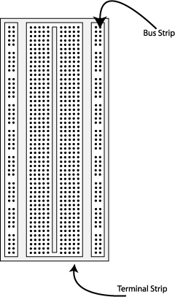    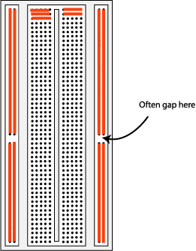

**Fig 1.** The breadboard. The lines indicate connected holes.

 The 5V supply **MUST NOT BE EXCEEDED** since this will damage the ICs (Integrated circuits) used during the experiments. Incorrect connection of power to the ICs could result in them exploding or becoming very hot - with the **possible serious injury occurring to the people working on the experiment! Ensure that the power supply polarity and all components and connections are correct before switching on power .**

**Building the Circuit**

Throughout these experiments we will use TTL chips to build circuits. The steps for wiring a circuit should be completed in the order described below:

|  |
| --- |
| 1. Turn the power (Trainer Kit) off before you build anything! |
| 1. Make sure the power is off before you build anything! |
| 1. Connect the +5V and ground (GND) leads of the power supply to the power and ground bus strips on your breadboard. |
| 1. Plug the chips you will be using into the breadboard. Point all the chips in the same direction with pin 1 at the upper-left corner. (Pin 1 is often identified by a dot or a notch next to it on the chip package) |
| 1. Connect +5V and GND pins of each chip to the power and ground bus strips on the breadboard. |
| 1. Select a connection on your schematic and place a piece of hook-up wire between corresponding pins of the chips on your breadboard. It is better to make the short connections before the longer ones. Mark each connection on your schematic as you go, so as not to try to make the same connection again at a later stage. |
| 1. Get one of your group members to check the connections, **before you turn the power on**. |
| 1. If an error is made and is not spotted before you turn the power on. Turn the power off immediately before you begin to rewire the circuit. |
| 1. At the end of the laboratory session, collect you hook-up wires, chips and all equipment and return them to the lab technician/ assisting staff. |
| 1. Tidy the area that you were working in and leave it in the same condition as it was before you started. |

**Common Causes of Problems**

|  |
| --- |
| 1. Not connecting the ground and/or power pins for all chips. |
| 1. Not turning on the power supply before checking the operation of the circuit. |
| 1. Leaving out wires. |
| 1. Plugging wires into the wrong holes. |
| 1. Driving a single gate input with the outputs of two or more gates |
| 1. Modifying the circuit with the power on. |

In all experiments, you will be expected to obtain all instruments, leads, components at the start of the experiment and return them to their proper place after you have finished the experiment. Please inform the lab technician if you locate faulty equipment. If you damage a chip, inform a lab technician/ assisting staff, don't put it back in the box of chips for somebody else to use.

DEPT. OF ELECTRICAL & ELECTRONICS ENGINEERING

SRM INSTITUTE OF SCIENCE AND TECHNOLOGY, Kattankulathur – 603 203

|  |
| --- |
| Title of Experiment : **1. Verification of Kirchhoff’s Laws** |
| Name of the candidate :  Register Number :  Date of Experiment : |

|  |  |  |  |
| --- | --- | --- | --- |
| Sl.  No. | Marks Split up | Maximum marks  (50) | Marks obtained |
| 1 | Pre Lab questions | 5 |  |
| 2 | Preparation of observation | 15 |  |
| 3 | Execution of experiment | 15 |  |
| 4 | Calculation / Evaluation of Result | 10 |  |
| 5 | Post Lab questions | 5 |  |
| **Total** | | **50** |  |

Staff Signature

**PRE LAB QUESTIONS**

**1. Define Ohm’s law.**

**2. State KCL and KVL.**

**3. Define absolute potential and potential difference**

**4. What is the difference between mesh and loop?**

**5. What is super-node?**

|  |  |
| --- | --- |
| **Experiment No. 1**  **Date :** | **VERIFICATION OF KIRCHOFF’S LAWS** |

**Aim:**

To verify Kirchhoff’s current law and Kirchhoff’s voltage law for the given circuit.

**Apparatus Required:**

|  |  |  |  |
| --- | --- | --- | --- |
| Sl.No. | Apparatus | Range | Quantity |
| 1 | RPS (regulated power supply) | (0-30V) | 2 |
| 2 | Resistance | 330Ω, 220Ω 1kΩ | 6 |
| 3 | Ammeter | (0-30mA)MC | 3 |
| 4 | Voltmeter | (0-30V)MC | 3 |
| 5 | Bread Board & Wires | -- | Required |

**Statement:**

**KCL:** The algebraic sum of the currents meeting at a node/junction is equal to zero.

**KVL:** In any closed path / mesh, the algebraic sum of all the voltages is zero.

**Precautions:**

1. Voltage control knob should be kept at minimum position.
2. Current control knob of RPS should be kept at maximum position.

**Procedure for KCL:**

1. Give the connections as per the circuit diagram.
2. Set a particular value in RPS.
3. Note down the corresponding ammeter reading
4. Repeat the same for different voltages

**Procedure for KVL:**

1. Give the connections as per the circuit diagram.
2. Set a particular value in RPS.
3. Note all the voltage reading
4. Repeat the same for different voltages

**HARDWARE SETUP:**

**Circuit for KCL verification:**

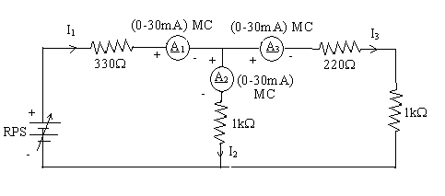

**Circuit for KVL verification:**

**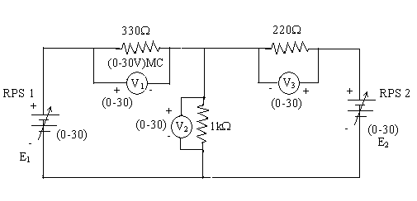**

**KCL - Theoretical Values:**

|  |  |  |  |  |  |
| --- | --- | --- | --- | --- | --- |
| Sl.  No. | Voltage  E | Current | | | I1 = I2 + I3 |
| I1 | I2 | I3 |
| Volts | mA | mA | mA | mA |
| 1 |  |  |  |  |  |
| 2 |  |  |  |  |  |
| 3 |  |  |  |  |  |
| 4 |  |  |  |  |  |
| 5 |  |  |  |  |  |

**KCL - Practical Values:**

|  |  |  |  |  |  |
| --- | --- | --- | --- | --- | --- |
| Sl.  No. | Voltage  E | Current | | | I1 = I2 + I3 |
| I1 | I2 | I3 |
| Volts | mA | mA | mA | mA |
| 1 |  |  |  |  |  |
| 2 |  |  |  |  |  |
| 3 |  |  |  |  |  |

**KVL – Theoretical Values**

|  |  |  |  |  |  |  |
| --- | --- | --- | --- | --- | --- | --- |
| Sl.No. | RPS | | Voltage | | | KVL  E1 = V1 + V2 |
| E1 | E2 | V1 | V2 | V3 |
| V | V | V | V | V | V |
| 1 |  |  |  |  |  |  |
| 2 |  |  |  |  |  |  |
| 3 |  |  |  |  |  |  |
| 4 |  |  |  |  |  |  |
| 5 |  |  |  |  |  |  |

**KVL - Practical Values**

|  |  |  |  |  |  |  |
| --- | --- | --- | --- | --- | --- | --- |
| Sl.No. | RPS | | Voltage | | | KVL  E1 = V1 + V2 |
| E1 | E2 | V1 | V2 | V3 |
| V | V | V | V | V | V |
| 1 |  |  |  |  |  |  |
| 2 |  |  |  |  |  |  |
| 3 |  |  |  |  |  |  |

**Model Calculations:**

**Result:**

**POST LAB QUESTIONS**

1. **Illustrate KCL and KVL.**
2. **Express the limitations of Ohm’s law?**
3. **What is the practical application of Kirchhoff’s law?**
4. **Compare series and parallel circuits**
5. **What is the difference between series and parallel connection of batteries?**

DEPT. OF ELECTRICAL & ELECTRONICS ENGINEERING

SRM INSTITUTE OF SCIENCE AND TECHNOLOGY, Kattankulathur – 603 203

|  |
| --- |
| Title of Experiment : **2. VERIFICATION OF ALL THEOREMS-**  **( THEVENIN,** NORTON,  MAXIMUM POWER TRANSFER ) |
| Name of the candidate :  Register Number :  Date of Experiment : |

|  |  |  |  |
| --- | --- | --- | --- |
| Sl.  No. | Marks Split up | Maximum marks  (50) | Marks obtained |
| 1 | Pre Lab questions | 5 |  |
| 2 | Preparation of observation | 15 |  |
| 3 | Execution of experiment | 15 |  |
| 4 | Calculation / Evaluation of Result | 10 |  |
| 5 | Post Lab questions | 5 |  |
| **Total** | | **50** |  |

Staff Signature

**PRE LAB QUESTIONS**

**1. Define Lumped and distributed elements.**

**2. State Thevenin’s theorem?**

**3. State Norton’s theorem?**

**4. List the applications of Thevenin’s and Norton’s theorems?**

**5. What are the different types of dependent or controlled sources?**

|  |  |
| --- | --- |
| **Experiment No. 2 a)**  **Date :** | **THEVENIN’S THEOREM** |

**Aim:**

To verify Thevenin’s theorem and to find the full load current for the given circuit.

**Apparatus Required:**

|  |  |  |  |
| --- | --- | --- | --- |
| Sl.No. | Apparatus | Range | Quantity |
| 1 | RPS (regulated power supply) | (0-30V) | 2 |
| 2 | Ammeter | (0-10mA) | 1 |
| 3 | Resistors | 1KΩ, 330Ω | 3,1 |
| 4 | Bread Board | -- | Required |
| 5 | DRB | -- | 1 |

**Statement:**

Any linear bilateral, active two terminal network can be replaced by a equivalent voltage source (VTH). Thevenin’s voltage or VOC in series with looking pack resistance RTH.

**Precautions:**

1. Voltage control knob of RPS should be kept at minimum position.
2. Current control knob of RPS should be kept at maximum position

**Procedure:**

1. Connections are given as per the circuit diagram.
2. Set a particular value of voltage using RPS and note down the corresponding ammeter readings.

**To find VTH**

1. Remove the load resistance and measure the open circuit voltage using multimeter (VTH).

**To find RTH**

1. To find the Thevenin’s resistance, remove the RPS and short circuit it and find the RTH using multimeter.
2. Give the connections for equivalent circuit and set VTH and RTH and note the corresponding ammeter reading.
3. Verify Thevenins theorem.

**Theoretical and Practical Values**

|  |  |  |  |  |  |
| --- | --- | --- | --- | --- | --- |
|  | E(V) | VTH(V) | RTH(Ω) | IL (mA) | |
| Circuit - I | Equivalent Circuit |
| Theoretical |  |  |  |  |  |
| Practical |  |  |  |  |  |

**Circuit - 1 : To find load current**

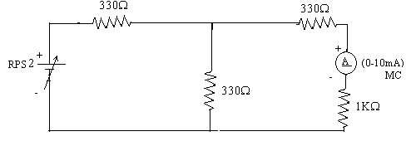

**To find VTH**

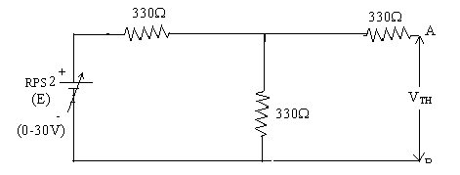

**To find RTH**

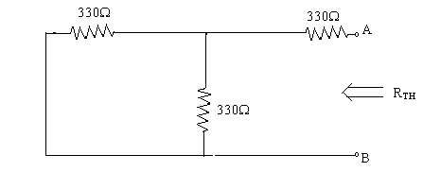

**Thevenin’s Equivalent circuit:**

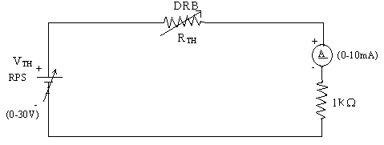

**Model Calculations:**

**Result:**

|  |  |
| --- | --- |
| **Experiment No. 2 b)**  **Date :** | **VERIFICATION OF NORTON’S THEOREM** |

**Aim:**

To verify Norton’s theorem for the given circuit.

**Apparatus Required:**

|  |  |  |  |
| --- | --- | --- | --- |
| Sl.No. | Apparatus | Range | Quantity |
| 1 | Ammeter | (0-10mA) MC  (0-30mA) MC | 1  1 |
| 2 | Resistors | 330, 1KΩ | 3,1 |
| 3 | RPS | (0-30V) | 2 |
| 4 | Bread Board | -- | 1 |
| 5 | Wires | -- | Required |

**Statement:**

Any linear, bilateral, active two terminal network can be replaced by an equivalent current source (IN) in parallel with Norton’s resistance (RN)

**Precautions:**

1. Voltage control knob of RPS should be kept at minimum position.
2. Current control knob of RPS should be kept at maximum position.

**Procedure:**

1. Connections are given as per circuit diagram.
2. Set a particular value in RPS and note down the ammeter readings in the original circuit.

**To Find IN:**

1. Remove the load resistance and short circuit the terminals.
2. For the same RPS voltage note down the ammeter readings.

**To Find RN:**

1. Remove RPS and short circuit the terminal and remove the load and note down the resistance across the two terminals.

**Equivalent Circuit:**

1. Set IN and RN and note down the ammeter readings.
2. Verify Norton’s theorem.

**To find load current in circuit 1:**

**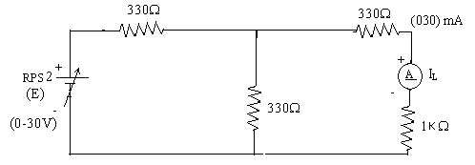**

**To find IN**

**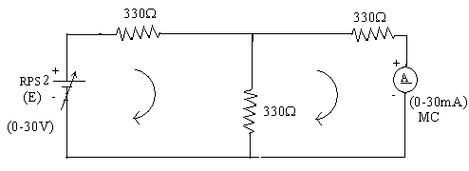**

**To find RN**

**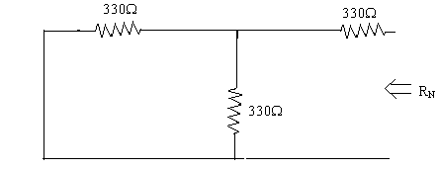**

**Norton’s equivalent circuit**

**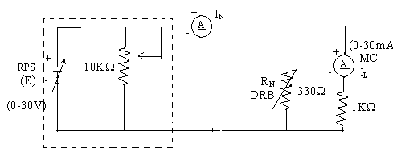**

Constant current source

**Theoretical and Practical Values**

|  |  |  |  |  |  |
| --- | --- | --- | --- | --- | --- |
|  | E  (volts) | IN  (mA) | RN  (Ω) | IL (mA) | |
| Circuit - I | Equivalent Circuit |
| Theoretical Values |  |  |  |  |  |
| Practical Values |  |  |  |  |  |

**Model Calculations:**

**Result:**

|  |  |
| --- | --- |
| **Experiment No. 2 c)**  **Date :** | **VERIFICATION OF MAXIMUM POWER TRANSFER THEOREM** |

**Aim:**

To verify maximum power transfer theorem for the given circuit

**Apparatus Required:**

|  |  |  |  |
| --- | --- | --- | --- |
| Sl.No. | Apparatus | Range | Quantity |
| 1 | RPS | (0-30V) | 1 |
| 2 | Voltmeter | (0-10V) MC | 1 |
| 3 | Resistor | 1KΩ, 1.3KΩ, 3Ω | 3 |
| 4 | DRB | -- | 1 |
| 5 | Bread Board & wires | -- | Required |

**Statement:**

In a linear, bilateral circuit the maximum power will be transferred from source to the load when load resistance is equal to source resistance.

**Precautions:**

1. Voltage control knob of RPS should be kept at minimum position.
2. Current control knob of RPS should be kept at maximum position.

**Procedure:**

**Circuit – I**

1. Connections are given as per the diagram and set a particular voltage in RPS.
2. Vary RL and note down the corresponding ammeter and voltmeter reading.
3. Repeat the procedure for different values of RL & Tabulate it.
4. Calculate the power for each value of RL.

**To find VTH:**

1. Remove the load, and determine the open circuit voltage using multimeter (VTH)

**To find RTH:**

1. Remove the load and short circuit the voltage source (RPS).
2. Find the looking back resistance (RTH) using multimeter.

**Equivalent Circuit:**

1. Set VTH using RPS and RTH using DRB and note down the ammeter reading.
2. Calculate the power delivered to the load (RL = RTH)
3. Verify maximum transfer theorem.

**Circuit - 1**

**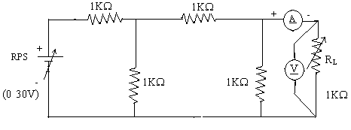**

**To find VTH**

**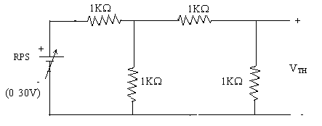**

**To find RTH**

**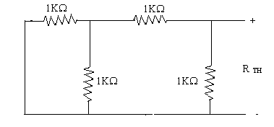**

**Thevenin’s Equation Circuit**

**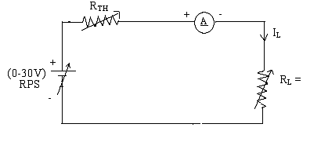**

**Power VS RL**

**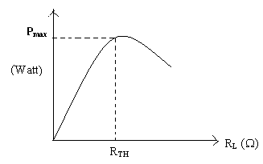**

**Circuit – I**

|  |  |  |  |  |
| --- | --- | --- | --- | --- |
| **Sl.No.** | **RL (Ω)** | **I (mA)** | **V(V)** | **P=VI (watts)** |
|  |  |  |  |  |

**To find Thevenin’s equivalent circuit**

|  |  |  |  |  |
| --- | --- | --- | --- | --- |
|  | **VTH (V)** | **RTH (Ω)** | **IL (mA)** | **P (milli watts)** |
| **Theoretical Value** |  |  |  |  |
| **Practical Value** |  |  |  |  |

**Model Calculations:**



**Result:**

**POST LAB QUESTIONS**

1. **State Thevenin’s Theorem.**
2. **Draw the Thevenin’s equivalent circuit**
3. **State maximum power transfer theorem.**
4. **Write some applications of maximum transfer theorem.**
5. **Write the steps to find IN**

**6. What are the steps to solve Maximum power transfer Theorem?**

DEPT. OF ELECTRICAL & ELECTRONICS ENGINEERING

SRM INSTITUTE OF SCIENCE AND TECHNOLOGY, Kattankulathur – 603 203

|  |
| --- |
| Title of Experiment : **3**.**Transient analysis of Series RL, RC circuits** |
| Name of the candidate :  Register Number :  Date of Experiment : |

|  |  |  |  |
| --- | --- | --- | --- |
| Sl.  No. | Marks Split up | Maximum marks  (50) | Marks obtained |
| 1 | Pre Lab questions | 5 |  |
| 2 | Preparation of observation | 15 |  |
| 3 | Execution of experiment | 15 |  |
| 4 | Calculation / Evaluation of Result | 10 |  |
| 5 | Post Lab questions | 5 |  |
| **Total** | | **50** |  |

Staff Signature

**PRE LAB QUESTIONS**

**1) Define Transient.**

**2) Time constant for RL Circuit.**

**3) Time constant for RC Circuit.**

**4) How will you design the values of L & C in a transient circuit?**

|  |  |
| --- | --- |
| **Experiment No. 3**  **Date :** | **Transient analysis of series RL, RC circuits** |

**Aim:**

To obtain the transient response and measure the time constant of a series RL and RC circuit for a pulse waveform.

**Apparatus Required:**

|  |  |  |  |
| --- | --- | --- | --- |
| Sl. No. | Apparatus | Range | Quantity |
| 1 | Function Generator | 800 Hz | 1 |
| 2 | Inductor | 1 mH | 1 |
| 3 | Resistor | 4 KΩ | 1 |
| 4 | Capacitor | 1 nF | 1 |
| 5 | Bread Board & Wires | -- | Required |
| 6 | CRO |  | 1 |
| 7 | CRO Probes |  | 2 |

**Theory**

In this experiment, we apply a pulse waveform to the RL or RC circuit to analyze the transient response of the circuit. The pulse-width relative to a circuit’s time constant determines how it is affected by an RC or RL circuit.

Time Constant (τ): A measure of time required for certain changes in voltages and currents in RC and RL circuits. Generally, when the elapsed time exceeds five time constants (5τ) after switching has occurred, the currents and voltages have reached their final value, which is also called steady-state response.

The time constant of an RC circuit is the product of equivalent capacitance and the Thevenin’s resistance as viewed from the terminals of the equivalent capacitor.

τ = RC

A Pulse is a voltage or current that changes from one level to the other and back again. If a waveform’s high time equals its low time, as in figure, it is called a square wave. The length of each cycle of a pulse train is termed its period (T). The pulse width (tp) of an ideal square wave is equal to half the time period.

**Procedure for RL:**

1. Make the connections as per the circuit diagram.
2. Choose square wave mode in signal generator
3. Using CRO, adjust the amplitude to be 2 volts peak to peak.
4. Take care of the precaution and set the input frequency.
5. Observe and plot the output waveform.
6. Calculate the time required by the output to reach 0.632 times the final value (peak).
7. This value gives the practical time constant. Tabulate the theoretical and practical values.

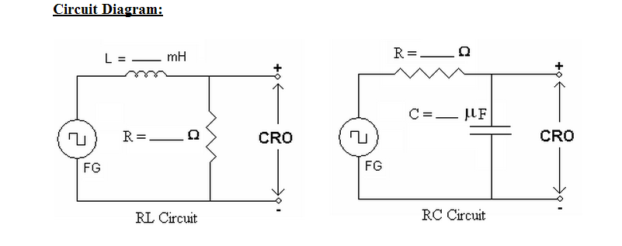

**Model Graph:**

**a) RL Transient :Output voltage across Resistor:**

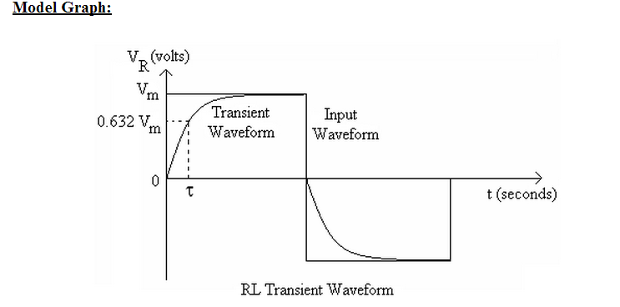

**b) RC Transient :Output voltage across Capacitor:**

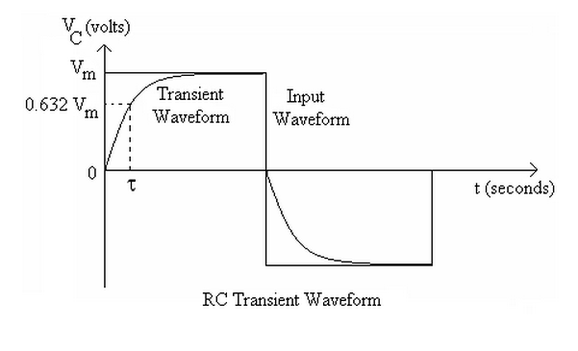

**Hardware setup:**

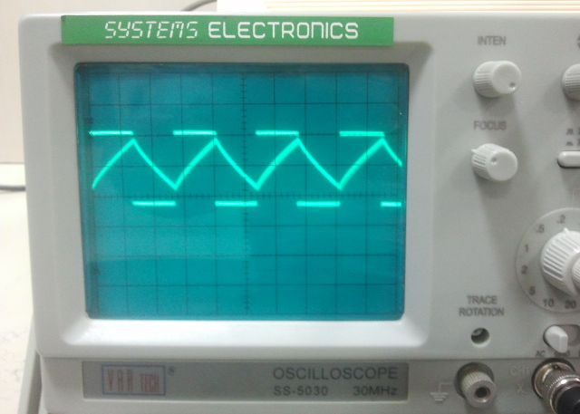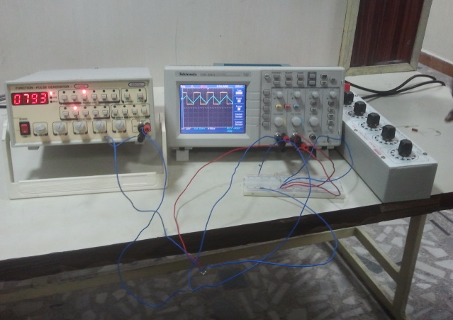





**Result:**

**POST LAB QUESTIONS**

**1) Why is it necessary to discharge the capacitor every time you want to record another transient voltage across the capacitor?**

**2) If the capacitor remains charged, what would you expect to see across the capacitor when you re-close the switch to try to record another transient?**

**3) What does the derivative of a step function look like?**

**4) What does the integral of a step function look like?**

DEPT. OF ELECTRICAL & ELECTRONICS ENGINEERING

SRM INSTITUTE OF SCIENCE AND TECHNOLOGY, Kattankulathur – 603 203

|  |
| --- |
| Title of Experiment : **4**. **LOAD TEST ON SINGLE PHASE TRANSFORMER** |
| Name of the candidate :  Register Number :  Date of Experiment : |

|  |  |  |  |
| --- | --- | --- | --- |
| Sl.  No. | Marks Split up | Maximum marks  (50) | Marks obtained |
| 1 | Pre Lab questions | 5 |  |
| 2 | Preparation of observation | 15 |  |
| 3 | Execution of experiment | 15 |  |
| 4 | Calculation / Evaluation of Result | 10 |  |
| 5 | Post Lab questions | 5 |  |
| **Total** | | **50** |  |

Staff Signature

**PRE LAB QUESTIONS**

1. **Explain the working principle of transformer**
2. **What are the main parts of a transformer?**
3. **What are the types of transformers?**
4. **What is the meaning of KVA rating of transformer?**
5. **What is the necessity of the load test for a transformer?**

**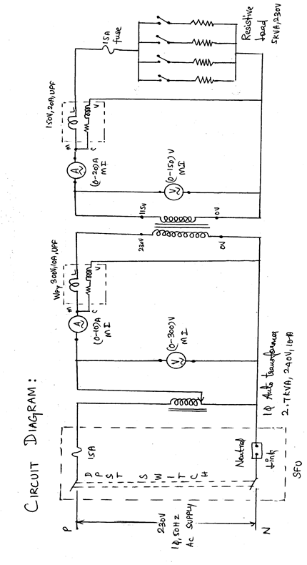**

|  |  |
| --- | --- |
| **Experiment No. 4**  **Date :** | **Load test on single phase transformer** |

**Aim**:

To conduct the load test on the given a single phase transformer for finding the efficiency and its regulation.

**Apparatus Required**:

|  |  |  |  |  |
| --- | --- | --- | --- | --- |
| S.NO | APPARATUS | RANGE | TYPE | QUANTITY |
| 1. | Voltmeter | (0-150)V  (0-300) V | MI  MI | 1  1 |
| 2. | Ammeter | (0-10)A  (0-20) A | MI  MI | 1  1 |
| 3. | Wattmeter | 150V,20A  300V,10A | UPF  UPF | 1  1 |
| 4. | Auto transformer | 240 V,  2.7 KVA,10A |  | 1 |

**Formula Used**:

1.Percentage Regulation = (Vo2-V2) /Vo2\*100

Where Vo2 = Secondary voltage on no load

Vo = Secondary voltage at a particular load

2. Power factor = Pout/V2\*I2

Where Pout = Secondary wattmeter readings in Watts

V2 = Secondary voltage in Volts

I2 = Secondary current in Amps

3. Percentage efficiency = Pout/Pin\*100

Where Pout = Secondary wattmeter readings in Watts

Pin = Primary wattmeter readings in Watts.

**Model Graph**:

% reg

**η**

Pout

**Procedure**

1.Connections are given as per the circuit diagram.

2.Verify whether the autotransformer is kept at zero voltage position.

3.By closing the DPST switch, 230V,1φ,50HZ AC supply is given to the transformer.

4.At no load, the readings from the meters are noted down.

5.The load is applied to the transformer in steps upto 125% of the rated value of the primary

Current by using rheostatic load..

6.The corresponding values from the meters are tabulated for different loads.

7.Then the load is removed gradually, auto transformer is brought to its minimum position and

the supply is switched off.

8.From the recorded values, the regulation, power factor and efficiency are calculated.

**TABULATION:**

|  |  |  |  |  |  |  |  |  |  |
| --- | --- | --- | --- | --- | --- | --- | --- | --- | --- |
| **S.**  **No** | **Primary Voltage**  **V1 (V)** | **Primary Current I1 (A)** | **Primary Wattmeter**  **W1 (W)** | **Secondary**  **Voltage**  **V2­ (V)** | **Secondary**  **Current**  **I2 (A)** | **Secondary Wattmeter**  **W2 (W)** | **Power**  **Factor Cosθ** | **%**  **Regulation**  **%** | **η**  **%** |
|  |  |  |  |  |  |  |  |  |  |
|  |  |  |  |  |  |  |  |  |  |
|  |  |  |  |  |  |  |  |  |  |
|  |  |  |  |  |  |  |  |  |  |
|  |  |  |  |  |  |  |  |  |  |
|  |  |  |  |  |  |  |  |  |  |

**Model Calculation:**



**Result**

**POST LAB QUESTIONS**

1. **What will happen if a DC voltage is given to the transformer primary?**
2. **What are the losses in a transformer?**
3. **How can we minimize the core losses in a transformer?**
4. **What is meant by eddy current losses?**
5. **How hysteresis loss can be reduced?**

DEPT. OF ELECTRICAL & ELECTRONICS ENGINEERING

SRM INSTITUTE OF SCIENCE AND TECHNOLOGY, Kattankulathur – 603 203

|  |
| --- |
| Title of Experiment : **5**. **Demo of DC/AC machine & Parts** |
| Name of the candidate :  Register Number :  Date of Experiment : |

|  |  |  |  |
| --- | --- | --- | --- |
| Sl.  No. | Marks Split up | Maximum marks  (50) | Marks obtained |
| 1 | Pre Lab questions | 5 |  |
| 2 | Preparation of observation | 15 |  |
| 3 | Execution of experiment | 15 |  |
| 4 | Calculation / Evaluation of Result | 10 |  |
| 5 | Post Lab questions | 5 |  |
| **Total** | | **50** |  |

Staff Signature

**PRE-LAB QUESTIONS**

**1. What are the major parts of the DC generators?**

**2. Give the classification of AC machines.**

**3. What is the use of brushes in DC motor?**

**4. In a DC machine, rectification process is carried out in order to get unidirectional output (DC). This rectification process is carried out by \_\_\_\_\_\_\_\_\_\_\_\_\_\_**

**5. Why the armature of DC motor is laminated?**

|  |  |
| --- | --- |
| **Experiment No. 5**  **Date :** | **. Demo of DC/AC machine & Parts** |

**Aim :** To know the construction of practical DC, AC machines and identify the parts

**DC Generator.**

A dc generator is an electrical machine which converts mechanical energy into direct current electricity. This energy conversion is based on the principle of production of dynamically induced emf. This article outlines basic construction and working of a DC generator.

**Construction of a DC Machine:**

Note: A DC generator can be used as a DC motor without any constructional changes and vice versa is also possible. Thus, a DC generator or a DC motor can be broadly termed as a DC machine. These basic constructional details are also valid for the construction of a DC motor. Hence, let's call this point as construction of a DC machine instead of just 'construction of a dc generator'.

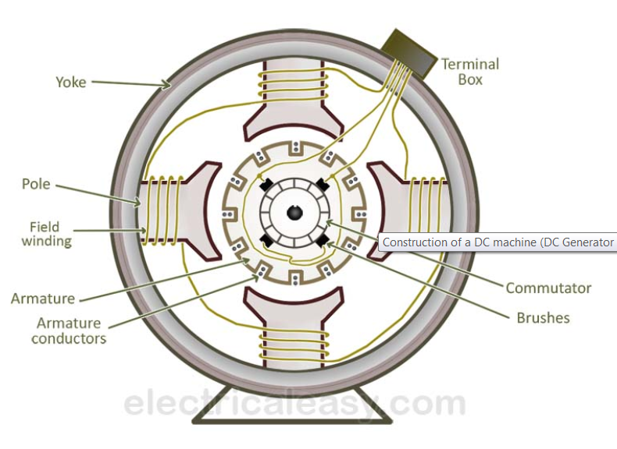

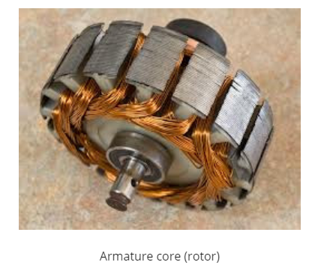

The above figure shows constructional details of a simple **4-pole DC machine**. A DC machine consists of two basic parts; stator and rotor. Basic constructional parts of a DC machine are described below.

1. **Yoke:** The outer frame of a dc machine is called as yoke. It is made up of cast iron or steel. It not only provides mechanical strength to the whole assembly but also carries the magnetic flux produced by the field winding.
2. **Poles and pole shoes:** Poles are joined to the yoke with the help of bolts or welding. They carry field winding and pole shoes are fastened to them. Pole shoes serve two purposes; (i) they support field coils and (ii) spread out the flux in air gap uniformly.
3. **Field winding:** They are usually made of copper. Field coils are former wound and placed on each pole and are connected in series. They are wound in such a way that, when energized, they form alternate North and South poles
4. **Armature core:** Armature core is the rotor of a dc machine. It is cylindrical in shape with slots to carry armature winding. The armature is built up of thin laminated circular steel disks for reducing eddy current losses. It may be provided with air ducts for the axial air flow for cooling purposes. Armature is keyed to the shaft.
5. **[Armature winding](https://www.electricaleasy.com/2012/12/armature-winding-of-dc-machine.html):** It is usually a former wound copper coil which rests in armature slots. The armature conductors are insulated from each other and also from the armature core. Armature winding can be wound by one of the two methods; lap winding or wave winding. Double layer lap or wave windings are generally used. A double layer winding means that each armature slot will carry two different coils.
6. **Commutator and brushes:** Physical connection to the armature winding is made through a commutator-brush arrangement. The function of a commutator, in a dc generator, is to collect the current generated in armature conductors. Whereas, in case of a dc motor, commutator helps in providing current to the armature conductors. A commutator consists of a set of copper segments which are insulated from each other. The number of segments is equal to the number of armature coils. Each segment is connected to an armature coil and the commutator is keyed to the shaft. Brushes are usually made from carbon or graphite. They rest on commutator segments and slide on the segments when the commutator rotates keeping the physical contact to collect or supply the current.

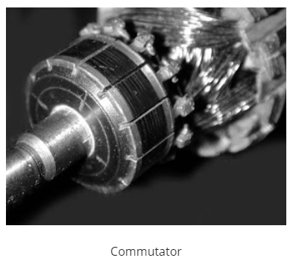

**CONSTRUCTION OF AC MACHINES (THREE PHASE INDUCTION MOTOR)**

The three phase induction motor is the most widely used electrical motor. Almost 80% of the mechanical power used by industries is provided by three phase induction motors because of its simple and rugged construction, low cost, good operating characteristics, the absence of commutator and good speed regulation. In three phase induction motor, the power is transferred from stator to rotor winding through induction. The induction motor is also called a synchronous motor as it runs at a speed other than the synchronous speed.

Like any other electrical motor induction motor also have two main parts namely rotor and stator.

**Stator**: As its name indicates stator is a stationary part of induction motor. A stator winding is placed in the stator of induction motor and the three phase supply is given to it.

**Rotor**: The rotor is a rotating part of induction motor. The rotor is connected to the mechanical load through the shaft.

The rotor of the three phase induction motor are further classified as

* Squirrel cage rotor,
* Slip ring rotor or wound rotor or phase wound rotor.

### STATOR OF THREE PHASE INDUCTION MOTOR

The stator of the three-phase induction motor consists of three main parts :

1. Stator frame,
2. Stator core,
3. Stator winding or field winding.

**PARTS OF AC MOTOR (3-PHASE INDUCTION MOTOR)**

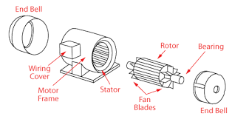

**3-Phase Induction Motor**

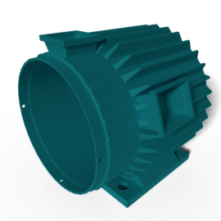

**STATOR FRAME**

### stator core

### STATOR CORE

### stator-winding

### STATOR WINDING OR FIELD WINDING

#### rotor of induction motor

#### SQUIRREL CAGE THREE PHASE INDUCTION MOTOR

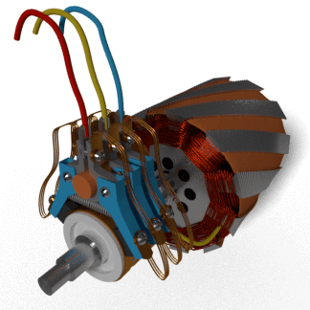

**SLIP RING OR WOUND ROTOR THREE PHASE INDUCTION MOTOR**

**POST-LAB QUESTIONS**

**1. Why we need starter for machines?**

**2. Name any four the domestic electrical machines with name plate details.**

**3. Difference between 3-phase squirrel cage and slip-ring induction motor?**

**4. What are the various types of rotors used in the alternators?**

**5. What are the applications of DC motors?**

DEPT. OF ELECTRICAL & ELECTRONICS ENGINEERING

SRM INSTITUTE OF SCIENCE AND TECHNOLOGY, Kattankulathur – 603 203

|  |
| --- |
| Title of Experiment : **6**. **Types of wiring (a)Fluorescent Lamp wiring,**  **(b) Stair case wiring** |
| Name of the candidate :  Register Number :  Date of Experiment : |

|  |  |  |  |
| --- | --- | --- | --- |
| Sl.  No. | Marks Split up | Maximum marks  (50) | Marks obtained |
| 1 | Pre Lab questions | 5 |  |
| 2 | Preparation of observation | 15 |  |
| 3 | Execution of experiment | 15 |  |
| 4 | Calculation / Evaluation of Result | 10 |  |
| 5 | Post Lab questions | 5 |  |
| **Total** | | **50** |  |

Staff Signature

**PRE LAB QUESTIONS**

1. **How does fluorescent lamp work?**
2. **What is the difference between fluorescent lamp and incandescent lamp?**
3. **What are the advantages of fluorescent light bulbs?**
4. **What is the voltage required to start a fluorescent lamp?**
5. **What is the function of starter in a fluorescent lamp?**

|  |  |
| --- | --- |
| **Experiment No. 6 a)**  **Date :** | **FLUORESCENT LAMP WIRING** |

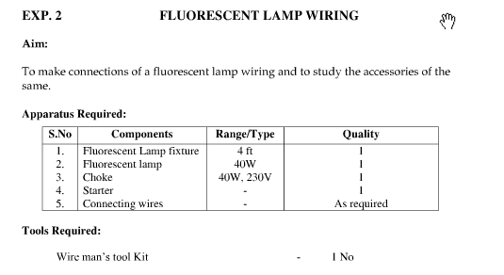

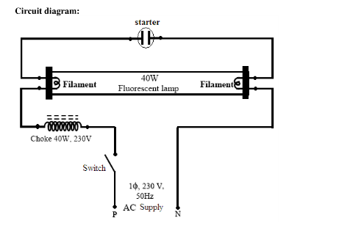

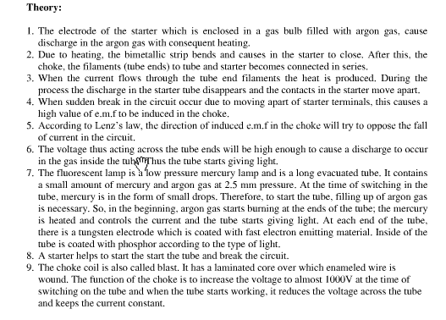

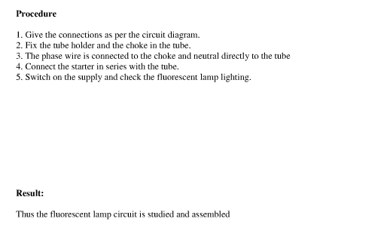

**Result**

|  |  |
| --- | --- |
| **Experiment No. 6 b)**  **Date :** | **6. b) STAIRCASE WIRING** |

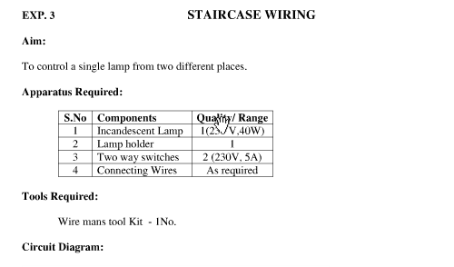

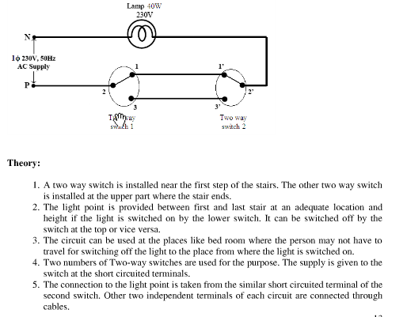

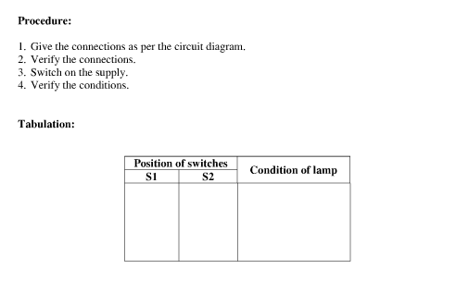

**Result**

**POST LAB QUESTIONS**

1. **What is the use of staircase wiring?**
2. **Why choke is used in fluorescent lamp?**
3. **What is the purpose of magnetic ballast in fluorescent lamp?**
4. **Compare electronic ballast and magnetic ballast?**
5. **List out the advantage of staircase wiring**

**DEPT. OF ELECTRICAL & ELECTRONICS ENGINEERING**

**SRM INSTITUTE OF SCIENCE AND TECHNOLOGY, Kattankulathur – 603203.**

|  |
| --- |
| Title of Experiment :7. **Characteristics of semiconductor devices**  **(a) PN junction diode, (b) Zener diode, (c)BJT** |
| Name of the candidate :  Register Number :  Date of Experiment :  Date of submission **:** |

|  |  |  |  |
| --- | --- | --- | --- |
| Sl.  No. | Marks Split up | Maximum marks  (50) | Marks obtained |
| 1 | Pre Lab questions | 5 |  |
| 2 | Preparation of observation | 15 |  |
| 3 | Execution of experiment | 15 |  |
| 4 | Calculation / Evaluation of Result | 10 |  |
| 5 | Post Lab questions | 5 |  |
| **Total** | | **50** |  |

**Staff Signature**

**PRE LAB QUESTIONS**

1. **What are intrinsic and extrinsic semiconductors?**

**2. Give examples for Trivalent and Pentavalent impurity.**

**3. What is the need for Zener diode?**

**4. What is voltage regulation and mention its significance?**

**5. Give the different types of semiconductor devices with symbols**

|  |  |
| --- | --- |
| **Experiment No. 7 a)**  **Date :** | **CHARACTERISTICS OF PN JUNCTION DIODE** |

**Aim**

To study the characteristics of PN Junction diode under forward and reverse bias conditions.

**Apparatus Required Components Required**

|  |  |  |  |  |  |  |  |  |
| --- | --- | --- | --- | --- | --- | --- | --- | --- |
| **S.No.** | **Name** | **Range** | **Qty** |  | **S.No.** | **Name** | **Range** | **Qty** |
| 1 | R.P.S | (0-30)V | 1 | 1 | Diode | IN4001 | 1 |
| 2 | Ammeter | (0–30)mA | 1 | 2 | Resistor | 1kΩ | 1 |
| (0-500)µA | 1 | 3 | Bread Board | - | 1 |
| 3 | Voltmeter | (0–1)V | 1 | 4 | connecting Wires | - | Req |
| (0-10)V | 1 |

**Theory**

A PN junction diode is a two terminal semiconducting device. It conducts only in one direction (only on forward biasing).

**Forward Bias**

On forward biasing, initially no current flows due to barrier potential. As the applied potential exceeds the barrier potential the charge carriers gain sufficient energy to cross the potential barrier and hence enter the other region. The holes, which are majority carriers in the P-region, become minority carriers on entering the N-regions, and electrons which are the majority carriers in the N-region, become minority carriers on entering the P-region. This injection of minority carriers results in the current flow, opposite to the direction of electron movement.

**Reverse Bias**

On reverse biasing, the majority charge carriers are attracted towards the terminals due to the applied potential resulting in the widening of the depletion region. Since the charge carriers are pushed towards the terminals no current flows in the device due to majority charge carriers. There will be some current in the device due to the thermally generated minority carriers. The generation of such carriers is independent of the applied potential and hence the current is constant for all increasing reverse potential. This current is referred to as Reverse Saturation Current (IO) and it increases with temperature. When the applied reverse voltage is increased beyond the certain limit, it results in breakdown. During breakdown, the diode current increases tremendously.

**Procedure**

**Forward Bias**

1. Connect the circuit as per the diagram.
2. Vary the applied voltage V in steps of 0.1V.
3. Note down the corresponding Ammeter readings I.
4. Plot a graph between V & I

**Observations**

1. Find the d.c (static) resistance = V/I.
2. Find the a.c (dynamic) resistance r = δV / δI (**r = ΔV/ΔI) = **.
3. Find the forward voltage drop [Hint: it is equal to 0.7 for Si and 0.3 for Ge]

**Reverse Bias**

1. Connect the circuit as per the diagram.
2. Vary the applied voltage V in steps of 1.0V.
3. Note down the corresponding Ammeter readings I.
4. Plot a graph between V & I
5. Find the dynamic resistance **r = δV / δI.**

**Formula for Reverse Saturation Current (IO):**

**Io  = ∂I/[exp(∂V/ηVT)]-1**

Where VT  is the voltage equivalent of Temperature = kT/q

-k is Boltzmann’s constant, q is the charge of the electron and T is the temperature in degrees Kelvin.

η =1 for Silicon and 2 for Germanium

**Circuit Diagram**

**Forward Bias**

**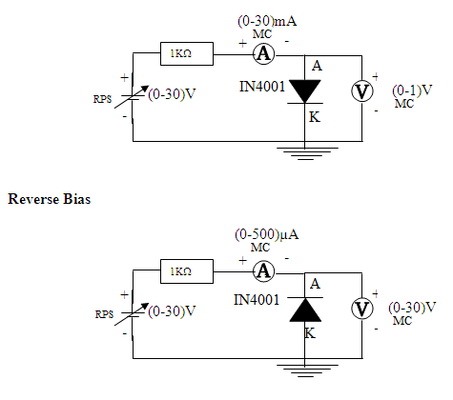**

**Specification for 1N4001: Silicon Diode**

Peak Inverse Voltage: 50V

Idc = 1A.

Maximum forward voltage drop at 1 Amp is 1.1 volts

Maximum reverse current at 50 volts is 5μA

|  |  |  |
| --- | --- | --- |
| **S.No.** | **Voltage**  **(In Volts)** | **Current**  **(In mA)** |
|  |  |  |
|  |  |  |
|  |  |  |
|  |  |  |
|  |  |  |
|  |  |  |
|  |  |  |
|  |  |  |
|  |  |  |
|  |  |  |
|  |  |  |

**Tabular Column**

**Forward Bias Reverse Bias**

|  |  |  |
| --- | --- | --- |
| **S.No.** | **Voltage**  **(In Volts)** | **Current**  **(In μA)** |
|  |  |  |
|  |  |  |
|  |  |  |
|  |  |  |
|  |  |  |
|  |  |  |
|  |  |  |
|  |  |  |
|  |  |  |
|  |  |  |
|  |  |  |
|  |  |  |
|  |  |  |

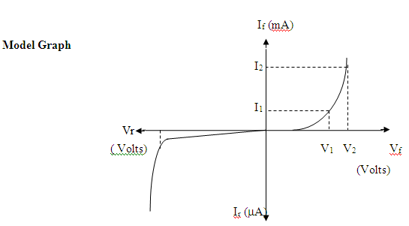



**Result**

|  |  |
| --- | --- |
| **Experiment No. 7 b)**  **Date :** | **CHARACTERISTICS OF ZENER DIODE** |

**Aim**

To find the forward and reverse bias characteristics of a given Zener diode.

**Apparatus Required Components Required**

|  |  |  |  |  |  |  |  |  |
| --- | --- | --- | --- | --- | --- | --- | --- | --- |
| **S.No.** | **Name** | **Range** | **Qty** |  | **S.No.** | **Name** | **Range** | **Qty** |
| 1 | R.P.S | (0-30)V | 1s | 1 | Zener diode | FZ5.1 | 1 |
| 2 | Ammeter | (0–30)mA | 2 | 2 | Resistor | 1KΩ | 1 |
| 3 | Bread Board | - | 1 |
| 3 | Voltmeter | (0–10)V | 1 | 4 | Wires | - | Req |
| (0–1)V | 1 |

**Theory**

A properly doped crystal diode, which has a sharp breakdown voltage, is known as Zener diode.

**Forward Bias**

On forward biasing, initially no current flows due to barrier potential. As the applied potential increases, it exceeds the barrier potential at one value and the charge carriers gain sufficient energy to cross the potential barrier and enter the other region. the holes ,which are majority carriers in p-region, become minority carriers on entering the N-regions and electrons, which are the majority carriers in the N-regions become minority carriers on entering the P-region. This injection of minority carriers results current, opposite to the direction of electron movement.

**Reverse Bias**

When the reverse bias is applied, due to majority carriers small amount of current (ie) reverse saturation current flows across the junction. As the reverse bias is increased to breakdown voltage, sudden rise in current takes place due to Zener effect.

**Zener Effect**

Normally, PN junction of Zener Diode is heavily doped. Due to heavy doping the depletion layer will be narrow. When the reverse bias is increased the potential across the depletion layer is more. This exerts a force on the electrons in the outermost shell. Because of this force the electrons are pulled away from the parent nuclei and become free electrons. This ionization, which occurs due to electrostatic force of attraction, is known as Zener effect. It results in large number of free carriers, which in turn increases the reverse saturation current

**Procedure**

**Forward Bias**

1. Connect the circuit as per the circuit diagram.

2. Vary the power supply in such a way that the readings are taken in steps of 0.1V in the voltmeter till the needle of power supply shows 30V.

3. Note down the corresponding ammeter readings.

4. Plot the graph :V (vs) I.

5. Find the dynamic resistance **r = δV / δI.**

**Reverse Bias**

1. Connect the circuit as per the diagram.
2. Vary the power supply in such a way that the readings are taken in steps of 0.1V in the voltmeter till the needle of power supply shows 30V.
3. Note down the corresponding Ammeter readings I.
4. Plot a graph between V & I
5. Find the dynamic resistance **r = δV / δI.**
6. Find the reverse voltage Vr at Iz=20 mA.

**Circuit Diagram**

**Forward Bias**

**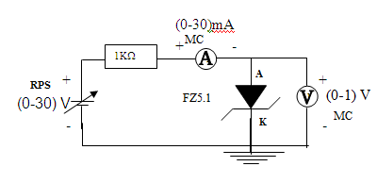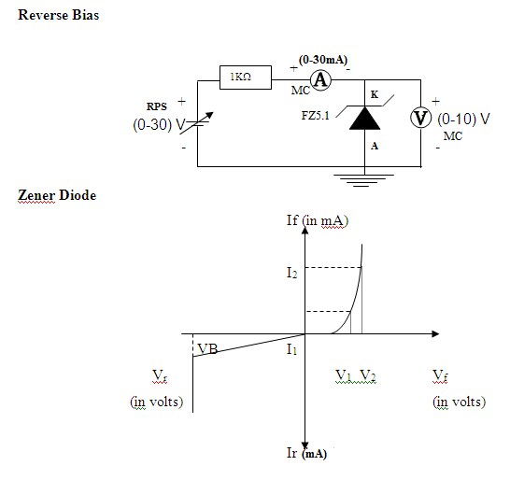**

# Tabular Column

**Forward Bias Reverse Bias**

|  |  |  |
| --- | --- | --- |
| **S.No.** | **Voltage**  **(In Volts)** | **Current**  **(In mA)** |
|  |  |  |
|  |  |  |
|  |  |  |
|  |  |  |
|  |  |  |
|  |  |  |
|  |  |  |
|  |  |  |
|  |  |  |
|  |  |  |

|  |  |  |
| --- | --- | --- |
| **S.No.** | **Voltage**  **(In Volts)** | **Current**  **(In mA)** |
|  |  |  |
|  |  |  |
|  |  |  |
|  |  |  |
|  |  |  |
|  |  |  |
|  |  |  |
|  |  |  |
|  |  |  |
|  |  |  |



**Result**

|  |  |
| --- | --- |
| **Experiment No. 7 c)**  **Date :** | **CHARACTERISTICS OF BJT (CE CONFIGURATION)** |

**Aim**

To plot the transistor (BJT) characteristics of CE configuration.

**Apparatus Required Components Required**

|  |  |  |  |  |  |  |  |  |
| --- | --- | --- | --- | --- | --- | --- | --- | --- |
| **S.No.** | **Name** | **Range** | **Qty** |  | **S.No.** | **Name** | **Range** | **Qty** |
| 1 | R.P.S | (0-30)V | 2 | 1 | Transistor | BC 107 | 1 |
| 2 | Ammeter | (0–30) mA  MC | 1 | 2 | Resistor | 10 KΩ | 1 |
| (0–250) µA  MC | 1 | Resistor | 1 KΩ | 1 |
| 3 | Voltmeter | (0–30)V  MC | 1 | 3 | Bread Board |  | 1 |
| (0–1)V  MC | 1 | 4 | Wires |  |  |

**Theory**

A BJT is a three terminal two – junction semiconductor device in which the conduction is due to both the charge carrier. Hence it is a bipolar device. BJT is classified into two types – NPN & PNP. A NPN transistor consists of two N types in between which a layer of P is sandwiched. The transistor consists of three terminal emitter, collector and base. The emitter layer is the source of the charge carriers and it is heavily doped with a moderate cross sectional area. The collector collects the charge carries and hence moderate doping and large cross sectional area. The base region acts a path for the movement of the charge carriers. In order to reduce the recombination of holes and electrons the base region is lightly doped and is of hollow cross sectional area. Normally the transistor operates with the EB junction forward biased.

**Procedure**

**Input Characteristics**

1. Connect the circuit as per the circuit diagram.
2. Set VCE, vary VBE in regular interval of steps and note down the corresponding IB reading. Repeat the above procedure for different values of VCE.
3. Plot the graph: VBE Vs IB for a constant VCE.

**Output Characteristics**

1. Connect the circuit as per the circuit diagram.
2. Set IB, Vary VCE in regular interval of steps and note down the corresponding IC reading. Repeat the above procedure for different values of IB.
3. Plot the graph: VCE Vs IC for a constant IB.

**Pin Diagram**

**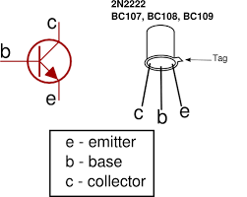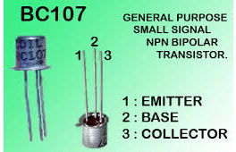**

Specification: BC107/50V/0.1A,0.3W,300 MH

**Circuit Diagram**

**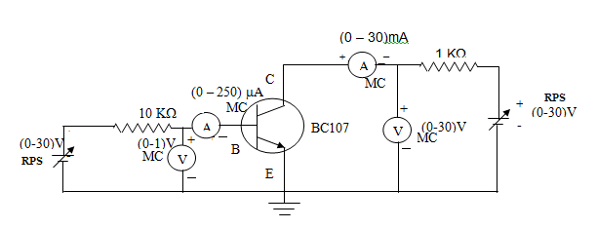 Model Graph**

**Input Characteristics Output Characteristics**

VCE = 0V

VCE = 5V

IB

µA

mA

VBE(V)

VCE(V)

0

0

IB=60μA

IB=40μA

IB=20μA

IC

**Tabular Column**

**Input Characteristics**

|  |  |  |  |
| --- | --- | --- | --- |
| **VCE = 0 V** | | **VCE = 2V** | |
| **VBE(V)** | **IB(μA)** | **VBE(V)** | **IB(μA)** |
|  |  |  |  |
|  |  |  |  |
|  |  |  |  |
|  |  |  |  |
|  |  |  |  |
|  |  |  |  |
|  |  |  |  |
|  |  |  |  |

**Output Characteristics**

|  |  |  |  |
| --- | --- | --- | --- |
| **IB=20μA** | | **IB=40μA** | |
|  |  |  |  |
|  |  |  |  |
|  |  |  |  |
|  |  |  |  |
|  |  |  |  |
|  |  |  |  |
|  |  |  |  |
|  |  |  |  |



Result

POST LAB QUESTIONS

**1 What is Punch through voltage?**

**2 What is early effect?**

**3 State maximum rating of transistor.**

**4. What is leakage current and mention its range?**

**5. What is base – width modulation?**

**DEPT. OF ELECTRICAL & ELECTRONICS ENGINEERING**

**SRM INSTITUTE OF SCIENCE AND TECHNOLOGY, Kattankulathur – 603203.**

|  |
| --- |
| Title of Experiment : **8. Wave shaping circuits ( Half wave & Full Rectifiers, Clippers)** |
| Name of the candidate :  Register Number :  Date of Experiment :  Date of submission **:** |

|  |  |  |  |
| --- | --- | --- | --- |
| Sl.  No. | Marks Split up | Maximum marks  (50) | Marks obtained |
| 1 | Pre Lab questions | 5 |  |
| 2 | Preparation of observation | 15 |  |
| 3 | Execution of experiment | 15 |  |
| 4 | Calculation / Evaluation of Result | 10 |  |
| 5 | Post Lab questions | 5 |  |
| **Total** | | **50** |  |

**Staff Signature**

**PRE LAB QUESTIONS (Rectifiers)**

**1 What is the necessity of rectifier?**

**2 What is PIV of a diode in Full Wave Rectifier (FWR) and Half Wave Rectifier (HWR)?**

**3 What is ripple factor? Why it is required?**

**4 Why are filters connected at the output of rectifiers?**

**5 What are the types of filters used in rectifier? And which is better and why?**

**Types of filters**

|  |  |
| --- | --- |
| **Experiment No. 8 a)**  **Date :** | **SINGLE PHASE HALF WAVE RECTIFIER** |

**Aim**

To construct a half wave rectifier using diode and to draw its performance characteristics.

**Apparatus Required Components Required**

|  |  |  |  |  |  |  |  |  |
| --- | --- | --- | --- | --- | --- | --- | --- | --- |
| **S.**  **No.** | **Name** | **Range** | **Qty** |  | **S.**  **No.** | **Name** | **Range** | **Qty** |
| 1 | Transformer | 230/(6-0-6)V | 1 | 1 | Diode | IN4007 | 1 |
| 2 | R.P.S | (0-30)V | 2 |
| 2 | Resistor | 1K Ω | 1 |
| 3 | Bread Board | - | 1 |
| 4 | Capacitor | 100µf | 1 |
| 5 | CRO | - | 1 |

**Formulae**

**With out Filter**

(i) Vrms = Vm / 2

(ii) Vdc = Vm / ∏

(iii) Ripple Factor = √ ((Vrms / Vdc)2 – 1)

(iv) Efficiency = (Vdc / Vrms)2 x 100

**With Filter**

(i) Vrms = √ (Vrms2 + Vdc2)

(ii) Vrms = Vrpp / (√3 x 2)

(iii) Vdc = Vm – V rpp / 2

(iv) Ripple Factor = Vrms / Vdc

**Procedure**

**Without Filter**

1. Give the connections as per the circuit diagram.
2. Give 230v, 50HZ I/P to the step down TFR where secondary connected to the Rectifier I/P.
3. Take the rectifier output across the Load.
4. Plot its performance graph.

**With Filter**

1. Give the connections as per the circuit diagram.

1. Give 230v, 50HZ I/P to the step down TFR where secondary connected to the Rectifier I/P.
2. Connect the Capacitor across the Load.
3. Take the rectifier output across the Load.
4. Plot its performance graph.

**Circuit Diagram**

***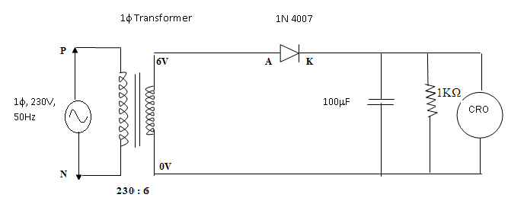***

**Tabular Column**

**Without Filter**

|  |  |  |  |  |
| --- | --- | --- | --- | --- |
| Vm (V) | Vrms (V) | Vdc (V) | Ripple factor | Efficiency |
|  |  |  |  |  |

**With Filter**

|  |  |  |  |
| --- | --- | --- | --- |
| Vrpp (V) | Vrms (V) | Vdc (V) | Ripple factor |
|  |  |  |  |

**Model Graph**

**V**in (Volts)

**t (ms)**

**V**o

(Volts)

**t (ms)**

**t (ms)**

**V**o

(Volts)

**Without Filter**

**With Filter**



**Result**

|  |  |
| --- | --- |
| **Experiment No. 8 b)**  **Date :** | **SINGLE PHASE FULL WAVE RECTIFIER** |

**Aim**

To construct a single phase full-wave rectifier using diode and to draw its performance characteristics.

**Apparatus Required Components Required**

|  |  |  |  |  |  |  |  |  |
| --- | --- | --- | --- | --- | --- | --- | --- | --- |
| **S.**  **No.** | **Name** | **Range** | **Qty** |  | **S.**  **No.** | **Name** | **Range** | **Qty** |
| 1 | Transformer | 230/(6-0-6)V | 1 | 1 | Diode | IN4007 | 2 |
| 2 | R.P.S | (0-30)V | 2 |
| 2 | Resistor | 1K Ω | 1 |
| 3 | Bread Board | - | 1 |
| 4 | Capacitor | 100µf | 1 |
| 5 | CRO | 1Hz-20MHz | 1 |
|  | 6 | Connecting wires | - | Req |

**Formulae**

**Without Filter**

(i) Vrms = Vm / √2

(ii) Vdc = 2Vm / ∏

(iii) Ripple Factor = √ ((Vrms / Vdc)2 – 1)

(iv) Efficiency = (Vdc / Vrms)2 x 100

**With Filter**

(i) Vrms = Vrpp /(2\*√ 3)

(ii) Vdc = Vm – V rpp

(iv) Ripple Factor = Vrms’/ Vdc

**Procedure**

**Without Filter**

1. Give the connections as per the circuit diagram.
2. Give 230v, 50HZ I/P to the step down TFR where secondary connected to the Rectifier I/P.
3. Take the rectifier output across the Load.
4. Plot its performance graph.

**With Filter**

* + - 1. Give the connections as per the circuit diagram.

1. Give 230v, 50HZ I/P to the step down TFR where secondary connected to the Rectifier I/P.
2. Connect the Capacitor across the Load.
3. Take the rectifier output across the Load.
4. Plot its performance graph.

**Circuit Diagram**

***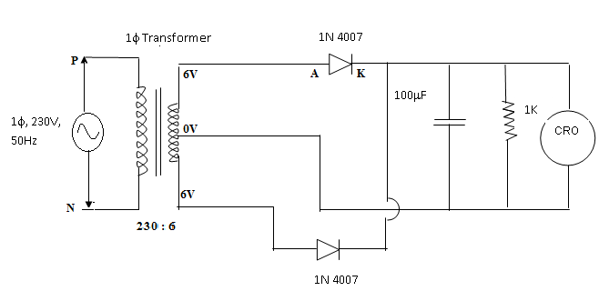***

**Tabular Column**

**Without Filter**

|  |  |  |  |  |
| --- | --- | --- | --- | --- |
| Vm | Vrms | Vdc | Ripple factor | Efficiency |
|  |  |  |  |  |

**With Filter**

|  |  |  |  |
| --- | --- | --- | --- |
| Vrms | Vrpp | Vdc | Ripple factor |
|  |  |  |  |

**Model Graph**

**V**in (Volts)

**t (ms)**

**V**o

(Volts)

**t (ms)**

**t (ms)**

**V**o

(Volts)

**Without Filter**

**With Filter**



**Result**

**POST LAB QUESTIONS**

**1. What is Transformer Utilization Factor (TUF)?**

**2. Mention the value of ripple factor for HWR, FWR & rectifier with centre tapped transformer.**

**3. What is the difference between uncontrolled rectifier and controlled rectifier? Which is advantageous and why?**

**4. State the average and peak value of output voltage and current for full wave rectifier and half wave rectifier.**

**5. What is PIV of a diode in half wave and full wave rectifier?**

**Clippers**

**PRE LAB QUESTIONS**

**1. What are the differences between linear and nonlinear wave shaping circuit?**

**2. What are the applications of wave shaping circuit?**

**3. What is wave shaping?**

**4. What is the necessity of wave shaping?**

**5. Mention the application of clipper and clamper.**

|  |  |
| --- | --- |
| **Experiment No. 8c)**  **Date :** | **CLIPPERS** |

**Aim**

To study the clipping circuits for different reference voltages and to verify the responses.

**Apparatus Required Components Required**

|  |  |  |  |  |  |  |  |  |
| --- | --- | --- | --- | --- | --- | --- | --- | --- |
| **S.No.** | **Name** | **Range** | **Qty** |  | **S.No.** | **Name** | **Range** | **Qty** |
| 1 | CRO | 1Hz-20MHz | 1 | 1 | Resistor | 10KΩ | 1 |
| 2 | RPS | (0–30) V | 1 |
| 3 | Bread Board | **-** | 1 |
| 4 | Connecting Wires | - | Req |  | 2 | Diode | IN4007 | 1 |
| 5 | Function Generator | 1Hz-1MHz | 1 |  |

**Theory**

The non-linear semiconductor diode in combination with resistor can function as clipper circuit. Energy storage circuit components are not required in the basic process of clipping. These circuits will select part of an arbitrary waveform which lies above or below some particular reference voltage level and that selected part of the waveform is used for transmission. So they are referred as voltage limiters, current limiters, amplitude selectors or slicers. There are three different types of clipping circuits.

1) Positive Clipping circuit.

2) Negative Clipping.

3) Positive and Negative Clipping (slicer).

In positive clipping circuit positive cycle of Sinusoidal signal is clipped and negative portion of sinusoidal signal is obtained in the output of reference voltage is added, instead of complete positive cycle that portion of the positive cycle which is above the reference voltage value is clipped. In negative clipping circuit instead of positive portion of sinusoidal signal, negative portion is clipped. In slicer both positive and negative portions of the sinusoidal signal are clipped.

**Procedure**

1. Connect the circuit as shown in the circuit diagram.

2. Connect the function generator at the input terminals and CRO at the output terminals of the circuit.

3. Apply a sine wave signal of frequency 1 KHz, Amplitude greater than the reference voltage at the input and observe the output waveforms of the circuits.

**Circuit Diagram**

**Positive Clipper**

**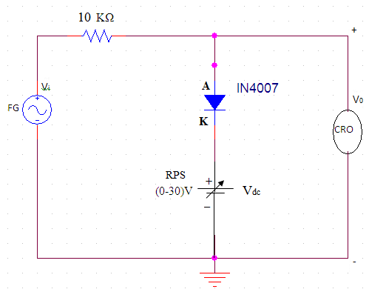**

**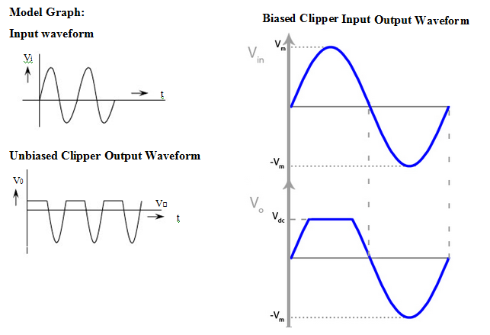**

**Negative Clipper**

**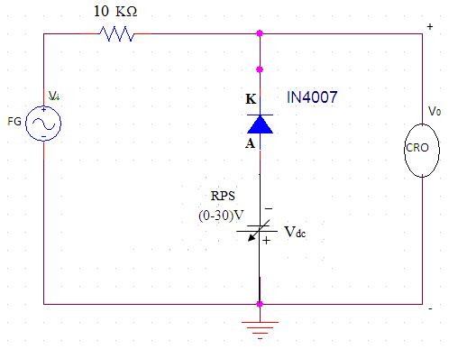**

**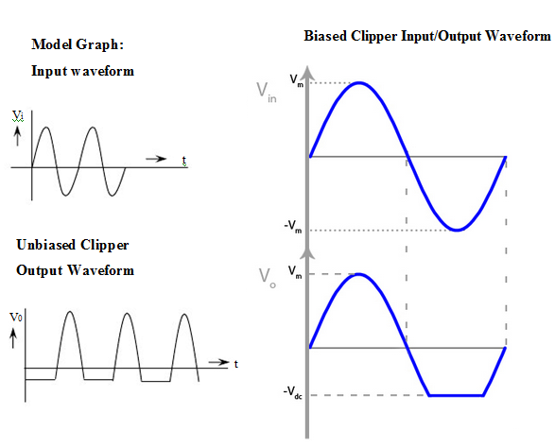**

**Tabulation:**

**Positive Clipper** **Negative Clipper**

|  |  |  |  |
| --- | --- | --- | --- |
| **Unbiased Clipper** | | | |
| **Vref = 0V** | | **Vref = 0V** | |
| **Output voltage**  **(V)** | **Time Period**  **(ms)** | **Output voltage**  **(V)** | **Time Period**  **(ms)** |
|  |  |  |  |
| **Biased Clipper** | | | |
| **Vref = 2V** | | **Vref = 2 V** | |
| **Output voltage**  **(V)** | **Time Period**  **(ms)** | **Output voltage**  **(V)** | **Time Period**  **(ms)** |
|  |  |  |  |



Result

**POST LAB QUESTIONS**

**1.** **Differentiate +ve and -ve Clippers.**

**2. What is the function of Clampers?**

**3. Write the classifications of clippers and clampers.**

**4. Draw the output for the given input to the clamper circuit**

**5. What is the need of wave shaping circuit?**

**DEPT. OF ELECTRICAL & ELECTRONICS ENGINEERING**

**SRM INSTITUTE OF SCIENCE AND TECHNOLOGY, Kattankulathur – 603203.**

|  |
| --- |
| Title of Experiment : **9.**  **Displacement measurement using LVDT and pressure measurement using Strain gauge** |
| Name of the candidate :  Register Number :  Date of Experiment :  Date of submission **:** |
|  |

|  |  |  |  |
| --- | --- | --- | --- |
| Sl.  No. | Marks Split up | Maximum marks  (50) | Marks obtained |
| 1 | Pre Lab questions | 5 |  |
| 2 | Preparation of observation | 15 |  |
| 3 | Execution of experiment | 15 |  |
| 4 | Calculation / Evaluation of Result | 10 |  |
| 5 | Post Lab questions | 5 |  |
| **Total** | | **50** |  |

**Staff Signature**

|  |  |
| --- | --- |
| **Experiment No. 9 a)**  **Date :** | **Displacement measurement using Linear Variable Differential Transformer** |

**Aim**: To measure the displacement and to determine the characteristics of LVDT (Linear Variable Differential Transformer).

**Apparatus required**: LVDT, Digital displacement indicator, Calibration jig (with micrometre).

**THEORY: LVDT (LINEAR VARIABLE DIFFERENTIAL TRANSFORMER)**

The most widely used inductive transducer to translate the linear motion into electrical signals is the linear variable differential transformer (LVDT). The basic construction of LVDT is shown in Figure 1.



Figure 1. Linear Variable Differential Transformer

The transformer consists of a single primary P and two secondary windings S1 and S2 wound on a cylindrical former. The secondary windings have equal number of turns and are identically placed on either side. A moveable soft iron core is placed inside the transformer. The displacement to be measured is applied to the arm attached to the soft iron core. In practice the arm is made of highly permeability, nickel iron which is hydrogen annealed. This gives low harmonics low null voltage and high sensitivity. This is slotted longitudinally to reduce eddy current losses. The assembly is placed in stainless steel housing and the end leads provides electrostatic and electromagnetic shielding. The frequency of AC applied to primary windings may be between 50 Hz to 20 kHz. Since the primary winding is excited by an alternating source, it produces an alternating magnetic field which in turn induces alternating current voltage in the two secondary windings. Figure 2 depicts a cross-sectional view of an LVDT. The core causes the magnetic field generated by the primary winding to be coupled to the secondary. When the core is centred perfectly between both secondary and the primary as shown, the voltage induced in each secondary is equal in amplitude and 180 degree out of phase. Thus the LVDT output (for the series-opposed connection shown in this case) is zero because the voltage cancels each other. E0 = Es1 - Es2 = 0.

****

Figure 2. View of LVDT Core and Windings

Displacing the core to the left causes the first secondary to be more strongly coupled to the primary than the second secondary. The resulting higher voltage of the first secondary in relation to the second secondary causes an output voltage that is in phase with the primary voltage. Likewise, displacing the core to the right causes the second secondary to be more strongly coupled to the primary than the first secondary. The greater voltage of the second secondary causes an output voltage to be out of phase with the primary voltage.

**Procedure**:

1. Plug power chord to AC mains 230 V, 50 Hz and switch on the instrument.
2. Place the READ/CAL switch at READ position.
3. Balance the amplifier with the help of zero knob so that display should read zero without connecting the LVDT to instrument.
4. Replace the READ/CAL switch at CAL position.
5. Adjust the calibration point by rotating CAL knob so display should read 10.00 i.e., maximum calibration range.
6. Again keep the READ/CAL switch at READ position and connect the LVDT cable to instrument.
7. Make mechanical zero by rotating the micrometre. Display will read (00.00) this is null balancing.
8. Give displacement with micrometre and observe the digital readings.
9. Plot the graph of micrometre reading v/s digital reading.

**Model Graph:**

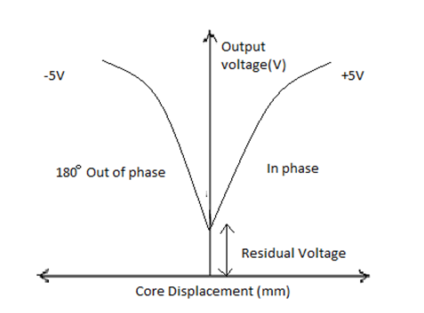

**Tabulations:**

|  |  |  |
| --- | --- | --- |
| **MICROMETER**  **DISPLACEMENT(mm)** | **CORE DISPLACEMENT**  **(mm)** | **SECONDARY OUTPUT**  **VOLTAGE(V)** |
|  |  |  |
|  |  |  |
|  |  |  |
|  |  |  |
|  |  |  |
|  |  |  |
|  |  |  |



**Result:**

**POST LAB QUESTIONS:**

**1. What are the three principles of Inductive transducers?**

**2. What are the limitations of LVDT?**

**3. Where LVDT is used?**

**4. What are the different types of transducers used for displacement measurement?**

**5. What is the difference between variable resistance & variable inductance displacement transducer?**

**PRE LAB QUESTIONS (Strain gauge):**

**1. How does a strain gauges work?**

**2. What is piezo-resistive effect?**

**3. What are the types of strain gauge?**

**4. Define gauge factor**

**5. Mention some practical applications of strain gauge**

|  |  |
| --- | --- |
| **Experiment No. 9 b)**  **Date :** | **Strain measurement using Strain gauge** |

**Aim**: To measure the strain using strain gauge.

**Apparatus Required**: Strain gauge, weight, LABVIEW software.

**Theory**: Strain is the amount of deformation of a body due to an applied force. More specifically, strain (e) is defined as the fractional change in length, Strain can be positive (tensile) or negative (compressive). Although dimensionless, strain is sometimes expressed in units such as in./in. or mm/mm. In practice, the magnitude of measured strain is very small. Therefore, strain is often expressed as microstrain (me), which is e x 10-6. When a bar is strained with a uniaxial force, as in Figure 1, a phenomenon known as Poisson Strain causes the girth of the bar, D, to contract in the transverse, or perpendicular, direction. The magnitude of this transverse contraction is a material property indicated by its Poisson's Ratio. The Poisson's Ratio n of a material is defined as the negative ratio of the strain in the transverse direction (perpendicular to the force) to the strain in the axial direction (parallel to the force), or n = eT/e. The most widely used gage is the bonded metallic strain gage. The metallic strain gauge consists of a very fine wire or, more commonly, metallic foil arranged in a grid pattern. The grid pattern maximizes the amount of metallic wire or foil subject to strain in the parallel direction (Figure 2). The cross-sectional area of the grid is minimized to reduce the effect of shear strain and Poisson Strain. The grid is bonded to a thin backing, called the carrier, which is attached directly to the test specimen.

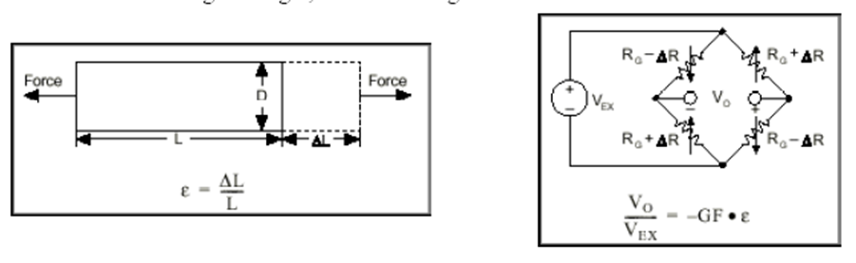

**Figure 1. Strain measurement**

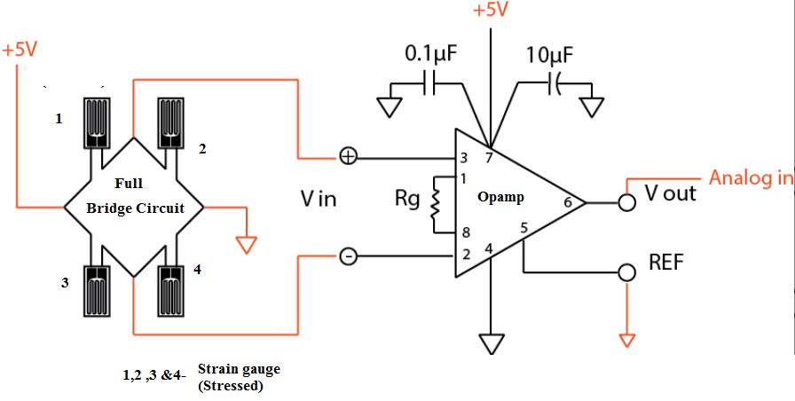

**Figure 2. Full- Bridge Strain gauge circuit**

**Procedure**:

1. Connect the cantilever strain measurement assembly to the main trainer and switch ON the trainer

2. Connect the multi meter at the Instrument output with multimeter in DC VOLTAGE mode and 20 V Range.

3. Connect this STRAIN output also to display section marked Vout.

4. Now without any strain or load in the cantilever beam. So adjust the OFFSET CONTROL to 0 volts at the output.

5. Now place 500 grams weights on the pan suspended n the beam and adjust the gain or call control to read 0.5 volt by multimeter at the strain output terminal.

6. Now remove the weight from the pan and the output must be 0 volt. IF not then readjust OFFSET Control

7. Table the readings for different weight or strain on the load cell as well as display readings.

**Tabulation:**

|  |  |  |  |  |
| --- | --- | --- | --- | --- |
| **S.no** | **Weight in Pan (Grams)** | **Voltage measured** | **Display reading** | **Calculated value** |
| **1** | **100** |  |  |  |
| **2** | **200** |  |  |  |
| **3** | **300** |  |  |  |
| **4** | **400** |  |  |  |
| **5** | **500** |  |  |  |
| **6** | **600** |  |  |  |
| **7** | **700** |  |  |  |
| **8** | **800** |  |  |  |
| **9** | **900** |  |  |  |
| **10** | **1000** |  |  |  |

**Result:**

**POST-LAB QUESTIONS:**

**1. How can you apply the principle of stain gauge?**

**2. What is meant by passive transducer?**

**3. What is sensitivity of strain gauge?**

**4. What is a microstrain?**

**5. What are the limitations of a strain gauge?**

**DEPT. OF ELECTRICAL & ELECTRONICS ENGINEERING**

**SRM INSTITUTE OF SCIENCE AND TECHNOLOGY, Kattankulathur – 603203.**

|  |
| --- |
| Title of Experiment : **10. Verification and interpretation of Logic Gates.** |
| Name of the candidate :  Register Number :  Date of Experiment : |

|  |  |  |  |
| --- | --- | --- | --- |
| Sl.  No. | Marks Split up | Maximum marks  (50) | Marks obtained |
| 1 | Pre Lab questions | 5 |  |
| 2 | Preparation of observation | 15 |  |
| 3 | Execution of experiment | 15 |  |
| 4 | Calculation / Evaluation of Result | 10 |  |
| 5 | Post Lab questions | 5 |  |
| **Total** | | **50** |  |

**Staff Signature**

**PRE-LAB QUESTIONS**

**1. Name the different Logic Gates.**

**2. List out the IC names for the different logic Gates.**

**3. What is the Boolean expression for a NOR gate?**

**4. How does a NOR gate work?**

**5. Expression for Ex-OR and Ex-NOR?**

|  |  |
| --- | --- |
| **Experiment No. 10**  **Date :** | **Verification and interpretation of truth tables for AND, OR, NOT, NAND, NOR Exclusive OR (EX-OR), Exclusive NOR (EX-NOR) Gates.** |

**Aim**: To verify the Boolean expression using logic gates.

**Apparatus:** Logic trainer kit, logic gates / ICs, wires.

**Theory:**  Logic gates are electronic circuits which perform logical functions on one or more inputs to produce one output. There are seven logic gates. When all the input combinations of a logic gate are written in a series and their corresponding outputs written along them, then this input/ output combination is called **Truth Table**. The following logic gates and their working are explained.

**i) AND Gate**

AND gate produces an output as 1, when all its inputs are 1; otherwise the output is 0. This gate can have minimum 2 inputs but output is always one. Its output is 0 when any input is 0.

[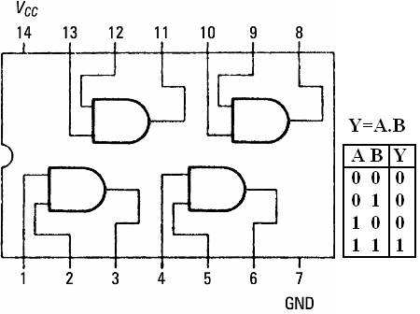](https://sites.google.com/site/amtmttl/st2/IC7408.PNG?attredirects=0)

**IC 7408**

**ii) OR Gate**

OR gate produces an output as 1, when any or all its inputs are 1; otherwise the output is 0. This gate can have minimum 2 inputs but output is always one. Its output is 0 when all input are 0.

[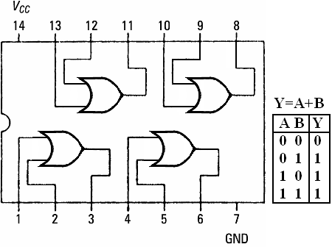](https://sites.google.com/site/amtmttl/st2/IC7432.PNG?attredirects=0)

IC 7432

**iii) NOT Gate**

NOT gate produces the complement of its input. This gate is also called an INVERTER. It always has one input and one output. Its output is 0 when input is 1 and output is 1 when input is 0.

[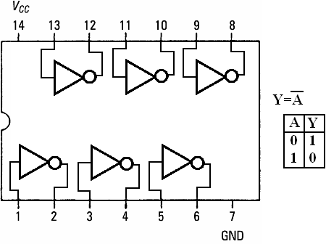](https://sites.google.com/site/amtmttl/st2/IC7404.PNG?attredirects=0)

IC 7404

**iv) NAND Gate**

NAND gate is actually a series of AND gate with NOT gate. If we connect the output of an AND gate to the input of a NOT gate, this combination will work as NOT-AND or NAND gate. Its output is 1 when any or all inputs are 0, otherwise output is 1.

[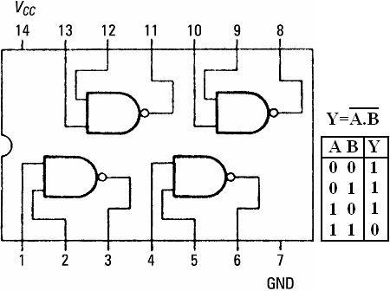](https://sites.google.com/site/amtmttl/st2/IC7400.png?attredirects=0)

**IC 7400**

**v) NOR Gate**

NOR gate is actually a series of OR gate with NOT gate. If we connect the output of an OR gate to the input of  a NOT gate, this combination will work as NOT-OR or NOR gate. Its output is 0 when any or all inputs are 1, otherwise output is 1.

[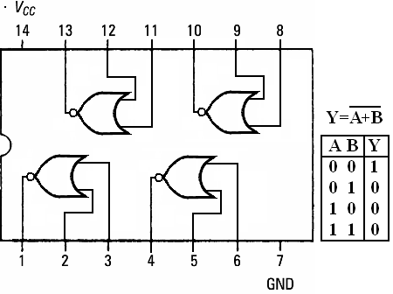](https://sites.google.com/site/amtmttl/st2/IC7402.PNG?attredirects=0)

**IC 7402**

**vi) Exclusive OR (X-OR) Gate**

X-OR gate produces an output as 1, when number of 1’s at its inputs is **odd**, otherwise output is 0. It has two inputs and one output.

[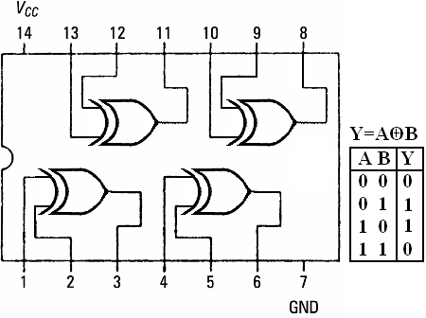](https://sites.google.com/site/amtmttl/st2/IC7486.PNG?attredirects=0)

**IC 7486**

**vii) Exclusive NOR (X-NOR) Gate**

X-NOR gate produces an output as 1, when number of 1’s at its inputs is **not odd**, otherwise output is 0. It has two inputs and one output.

[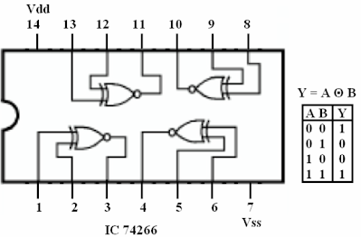](https://sites.google.com/site/amtmttl/st2/IC74266.PNG?attredirects=0)

**Procedure:**

1. Connect the trainer kit to ac power supply.
2. Connect the inputs of any one logic gate to the logic sources and its output to the logic indicator.
3. Apply various input combinations and observe output for each one.
4. Verify the truth table for each input/ output combination.
5. Repeat the process for all other logic gates.
6. Switch off the ac power supply.

**POST-LAB QUESTIONS**

**1. Name the universal Gates?**

**2.** **Deduce the logic of AND gate using NAND and NOR?**

**3. What is the symbol of NAND gate?**

**4. How many NAND gates are required to make an OR gate?**

**5. How many NOR gates are required to implement a NAND gate?**

**DEPT. OF ELECTRICAL & ELECTRONICS ENGINEERING**

**SRM INSTITUTE OF SCIENCE AND TECHNOLOGY, Kattankulathur – 603203.**

|  |
| --- |
| Title of Experiment : **11. Reduction of Boolean expression using K-map** |
| Name of the candidate :  Register Number :  Date of Experiment : |

|  |  |  |  |
| --- | --- | --- | --- |
| Sl.  No. | Marks Split up | Maximum marks  (50) | Marks obtained |
| 1 | Pre Lab questions | 5 |  |
| 2 | Preparation of observation | 15 |  |
| 3 | Execution of experiment | 15 |  |
| 4 | Calculation / Evaluation of Result | 10 |  |
| 5 | Post Lab questions | 5 |  |
| **Total** | | **50** |  |

**Staff Signature**

**PRE LAB QUESTIONS:**

**1. How many Cells are in 4 and 5 Variable K- Map.**

**2. What do you mean by don’t care condition in K-map or truth table?**

**3. Write the Distributive property of Boolean Algebra.**

**4. Write down the De Morgan law.**

**5. State the difference between SOP and POS.**

|  |  |
| --- | --- |
| **Experiment No. 11**  **Date :** | **Reduction of Logic Expression using**  **Karnaugh map** (**K- Map)** |

**Aim:** To simply and verify the Boolean expression using K-map.

**Apparatus:** Logic trainer kit, logic gates / ICs, wires.

**Theory:**

**Karnaugh maps:** Karnaugh maps or K-maps for short, provide another means of simplifying and optimizing logical expressions. This is a graphical technique that utilizes a sum of product (SOP) form. SOP forms combine terms that have been ANDed together that then get ORed together. This format lends itself to the use of De Morgan's law which allows the final result to be built with only NAND gates. The K-map is best used with logical functions with four or less input variables. One of the advantages of using K-maps for reduction is that it is easier to see when a circuit has been fully simplified. Another advantage is that using K-maps leads to a more structured process for minimization. In order to use a K-map, the truth table for a logical expression is transferred to a K-map grid. The grid for two, three, and four input expressions are provided in the tables below. Each cell corresponds to one row in a truth table or one given state in the logical expression. The order of the items in the grid is not random at all; they are set so that any adjacent cell differs in value by the change in only one variable. Because of this, items can be grouped together easily in rectangular blocks of two, four, and eight to find the minimal number of groupings that can cover the entire expression. Note that diagonal cells require that the value of more than two inputs change, and that they also do not form rectangles.

|  |  |  |  |  |
| --- | --- | --- | --- | --- |
|  | A'B’  00 | A’B  01 | AB  11 | AB’  10 |
| C’  0 |  |  |  |  |
| C  1 |  |  |  |  |

|  |  |  |
| --- | --- | --- |
|  | A’  0 | A  1 |
| B’  0 |  |  |
| B  1 |  |  |

**Figure 1. Three variables K Map Figure 2. Two variables K- Map**

**Given expression**

**F(C,A,B) = CAB + C'AB + CA'B + C'A'B**

**Simplification Using Boolean Properties**

CAB + C'AB + CA'B + C'A'B = AB(C + C') + A'B(C + C') Distributive Property

= AB + A'B C + C' is always true

= (A + A')B Distributive Property

= B A + A' is always true

**Simplification using K- Map**

****

**Procedure:**

1. Connect the trainer kit to ac power supply.
2. Connect the circuit based on the given logic functions to be simplified.
3. Connect the inputs of first stage to logic sources and output of the last gate to logic indicator.
4. Apply various input combinations and observe output for each one.
5. Verify the output before and after reducing the expression.
6. Switch off the ac power supply.

**Result:**

**Post-lab questions**

**1. Simply the expression F=AB+A­B’**

**2. Name the different reduction techniques**

**3. Give the merits and demerits of K-map**

**4. What are differences between K-map and Quine McCluskey?**

**5. Give steps for reducing two variable expression using K-map?**

**DEPT. OF ELECTRICAL & ELECTRONICS ENGINEERING**

**SRM INSTITUTE OF SCIENCE AND TECHNOLOGY, Kattankulathur – 603203.**

|  |
| --- |
| Title of Experiment : **12. Study of modulation and demodulation techniques.** |
| Name of the candidate :  Register Number :  Date of Experiment :  Date of submission **:** |

|  |  |  |  |
| --- | --- | --- | --- |
| Sl.  No. | Marks Split up | Maximum marks  (50) | Marks obtained |
| 1 | Pre Lab questions | 5 |  |
| 2 | Preparation of observation | 15 |  |
| 3 | Execution of experiment | 15 |  |
| 4 | Calculation / Evaluation of Result | 10 |  |
| 5 | Post Lab questions | 5 |  |
| **Total** | | **50** |  |

**Staff Signature**

**PRE-LAB QUESTIONS**

**1. What is meant by modulation and demodulation in communication?**

**2. What is modulation and demodulation?**

**3. What is modulation and what is the purpose of it?**

**4. Compare AM and FM**

**5. What is the difference between a modem and router?**

|  |  |
| --- | --- |
| **Experiment No. 12**  **Date :** | **Study of modulation and demodulation techniques.** |

**Aim**: To study the different modulation and demodulation techniques

# Theory:

# Modulation and demodulation

Communication is the basic attraction of mankind as it gives the knowledge of what is going on around us. In our daily life, we communicate with many people and use the entertainment media like television, radio, internet and newspaper to get ourselves involved. These entertainment media act as a source of communication**. [Electronic communication](http://www.edgefx.in/latest-zigbee-communication-based-projects-for-patients-monitoring/" \t "_blank)** comprises TV, radio, internet, etc. When we want to transmit a signal from one location to another, we have to strengthen the signal. After undergoing strengthening process the signal travels to a long distance. This is called as modulation, and this article gives an overview of the modulation and [types of modulation techniques](http://www.elprocus.com/different-types-of-modulation-techniques-in-communication-systems/" \t "_blank).

Communication is nothing but, the process of exchanging (two way communication) or passing (one way communication) information from one person to another. The basic electronic communication system consists of these components: transmitter, receiver and communication channel.

**Types of Modulation**

Communication is the basic attraction of mankind as it gives the knowledge of what is going on around us. In our daily life, we communicate with many people and use the entertainment media like television, radio, internet and newspaper to get ourselves involved. These entertainment media act as a source of communication. Electronic communication comprises TV, radio, internet, etc. When we want to transmit a signal from one location to another, we have to strengthen the signal. After undergoing strengthening process the signal travels to a long distance. This is called as modulation, and this article gives an overview of the modulation and types of modulation techniques.

Communication is nothing but, the process of exchanging (two way communications) or passing (one way communication) information from one person to another. The basic electronic communication system consists of these components: transmitter, receiver and communication channel.

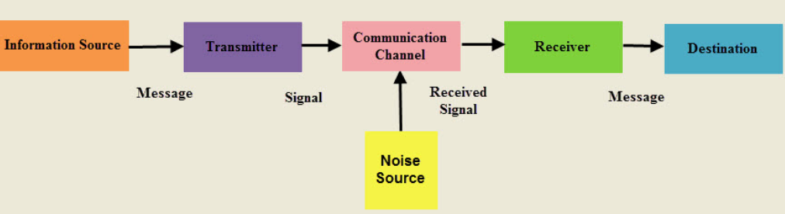

Figure 1. Communication System

A transmitter is a group of electronic circuits designed to convert the information into a signal for transmission over a given communication medium.

A receiver is a group of electronic circuits designed to convert the signal back to the original information.

The communication channel is the medium which is designed to transmit the electronic signal from one place to another.

Modulation is a way of sending signals of low frequency over long distances without a huge loss of energy by the use of another wave of very high frequency called a carrier wave.

Modulation is nothing but, a carrier signal that varies in accordance with the message signal. Modulation technique is used to change the signal characteristics. Basically, the modulation is of following two types:

* Analog Modulation
* Digital Modulation

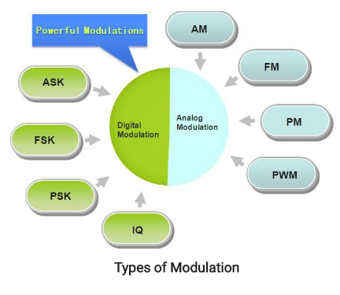

Figure 1. Types of Modulation

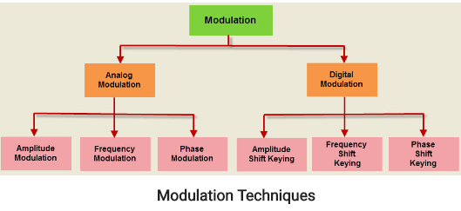

Figure 2. Modulation Techniques

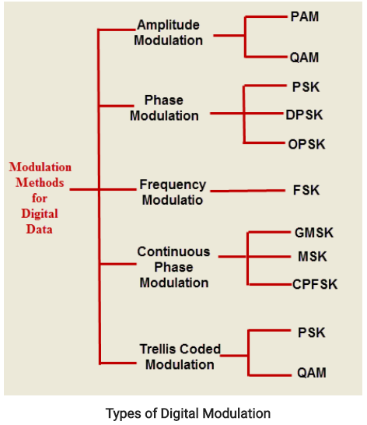

Figure 3. Types of Digital Modulation Techniques

High frequency signals are more directional and because high frequency waves have a small wavelength there is less diffraction. Also smaller aerials are needed because the size of the aerial has to be of the same sort of size as the wavelength of the signal to be transmitted.

Therefore a sound with a frequency of 256 Hz (middle C) received by a microphone, converted to an electrical signal and then transmitted would have a wavelength of 300000000/256 = 1 170 000 m, over 1000 km!

However a wave of frequency 100 MHz has a wavelength of only 3 m.

We can compare amplitude modulation with a long tube of soft clay on a conveyor belt. The clay moves between the hands of two people, one at each end of the belt.

Modulation – the person at one end moulds the clay by pressing on it as it moves between their hands. By squeezing and relaxing they make a tube of clay with a changing diameter.

At the other end of the belt there is a person with their eyes shut and their hands on either side of the clay at the other end. As the clay moves past their hands are forced in and out by the changing diameter of the clay cylinder. This is called detection

In reality we start with a carrier wave of very high frequency and add to it the audio signal (of relatively low frequency). This addition of the audio signal is called modulation. This can be done either by changing the amplitude of the carrier wave (amplitude modulation) or by changing its frequency (frequency modulation).

The audio signal is produced (Figure 1) and converted to an electrical signal by the microphone.

Figure 1

The high frequency carrier wave (with a frequency of say 100 MHz) (Figure 2) is produced by the transmitter.

Figure 2

These two signals are added together (modulation) (Figure 3).

Figure 3

The modulated signal is transmitted (Figure 4).

Figure 4

The modulated signal is received by the aerial.

A diode is used to separate the high frequency carrier wave from the low frequency audio signal (demodulation) by removing half the signal. This leaves the outline of the audio signal (Figure 5).

Figure 5

This signal is now amplified and fed to a loudspeaker.

The receiver is tuned to the carrier wave frequency. The following two diagrams (Figures 6 and 7) show two carrier waves of different frequency both modulated by the same frequency audio signal.

Figures 6 and 7

**Result :**

**POST-LAB QUESTIONS**

**1. What are the different types of modulation?**

**2. Which type of modulation is used in television?**

**3. What is PPM modulation?**

**4. What is PWM modulation?**

**5. What are NTSC and PAL?**